1923636

Ellaine Fontamillas

Faculty of Engineering and Technology

Department of Computing

Linux Essentials

C6-LIE-19

Lecturer: Mr. Lerato Masupha

End Assessment Paper

CONTENT

1. INTRODUCTION
2. BODY – HOW THE SYSTEM WORKS
3. COMMAND LINE / OUTPUT - SCREENSHOT
4. CONCLUSION
5. REFERENCE
6. **INTRODUCTION**

This is my final ICA report that consists of both written and practical approach. It uses skills acquired both inside the educational institute of Botho University and independent online research.

1. **BODY**

The project is a functional Linux-based application

* It is an Administration system application in the shell
* It is for BAT (Better Africa for Tomorrow)
* It aims to track available natural resources for the SADC countries
* And the management of these resources

The functions included are:

* Registering
* Retrieving
* Updating
* Deleting
* Capturing resources

1. **COMMAND LINE / OUTPUT**
2. I created a folder called **BAT** in Documents directory. It is where I will store all the necessary script files.

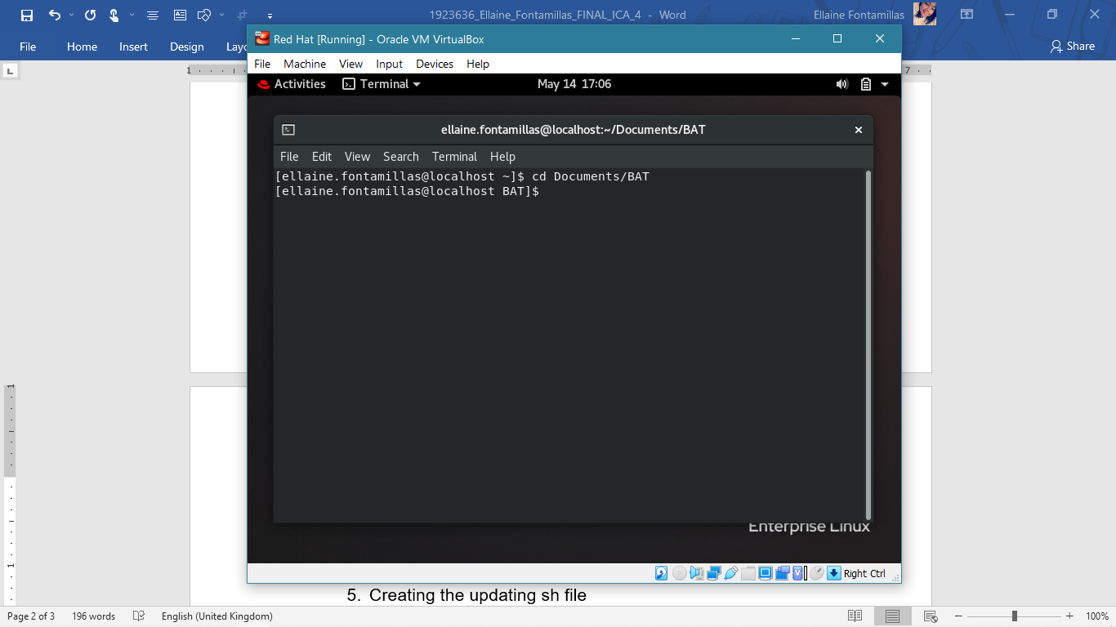

1. Creating the dashboard sh file

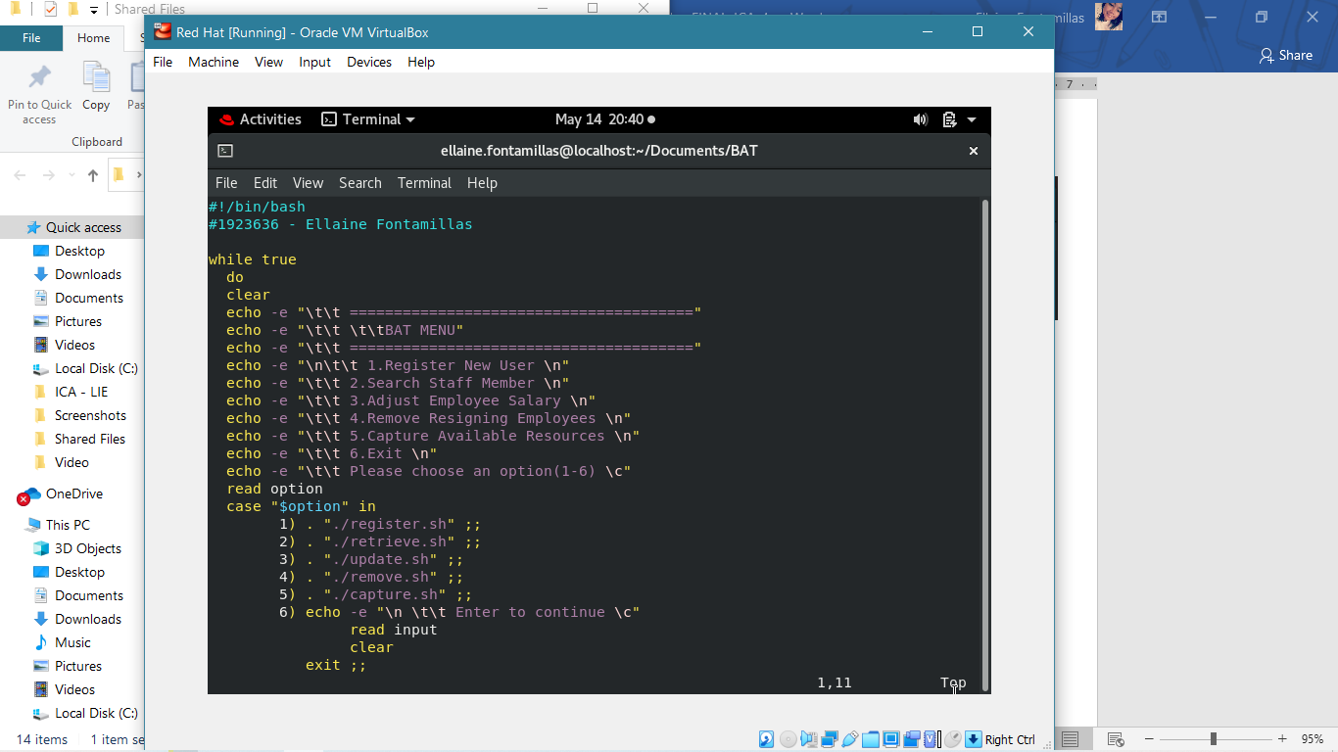

This is the **dashboard.sh** file. It uses a loop to display a menu.

The menu shows 6 options:

* Register
* Search
* Adjust/Update
* Remove
* Capture
* And Exit

Within the loop it uses case statement to **call** the respective functions in the shell files needed by the client for their system.

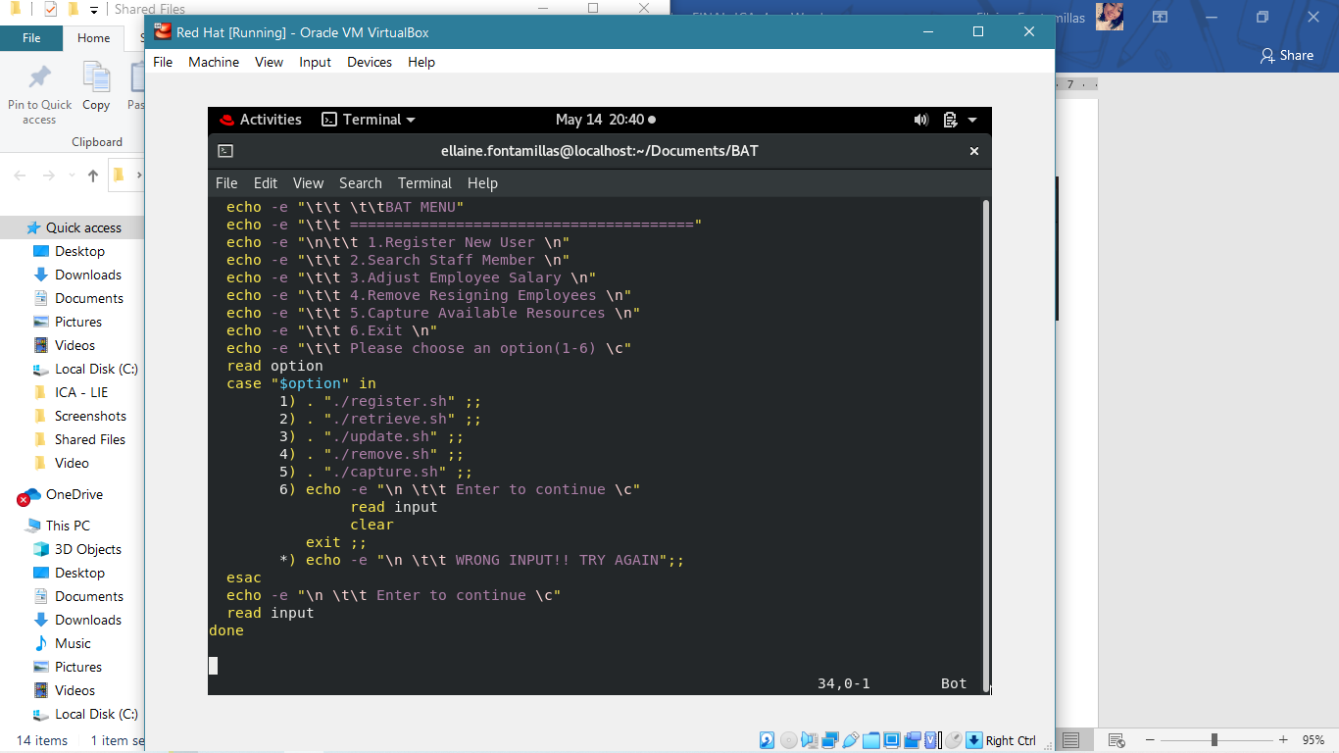

1. Creating registry sh file

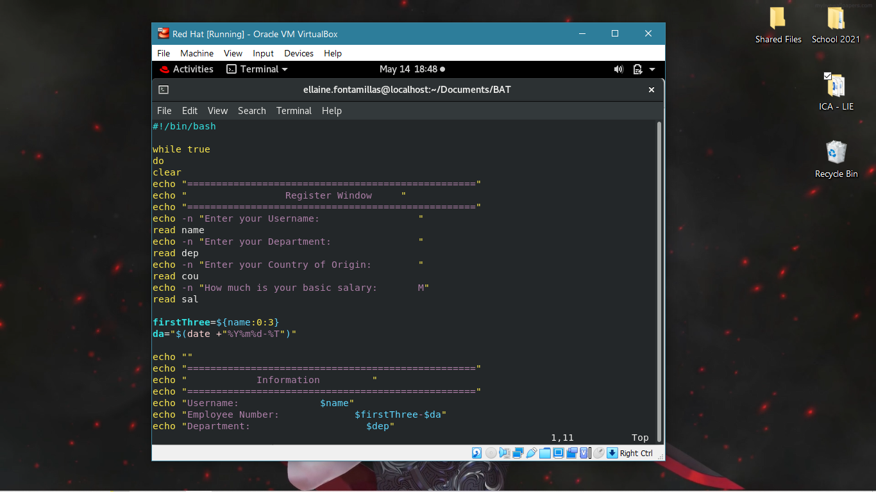

This is the **register.sh** file that takes the

* **Username**

which uses the first three letters (using $firstThree) and **JOIN** it with the date and time (using $da) to make the **Employee Number**

* **Department**
* **Country**
* **Salary**

After entering the details, it will **display** them and prompt the user to **confirm** if the details are correct.

Using case statement, if the details are correct, it will insert all the details into **CurrentEmployees.txt**

If the details are incorrect, it will use the **loop** to get the details again until it is correct.

That is when the user will be told that they are **exiting**

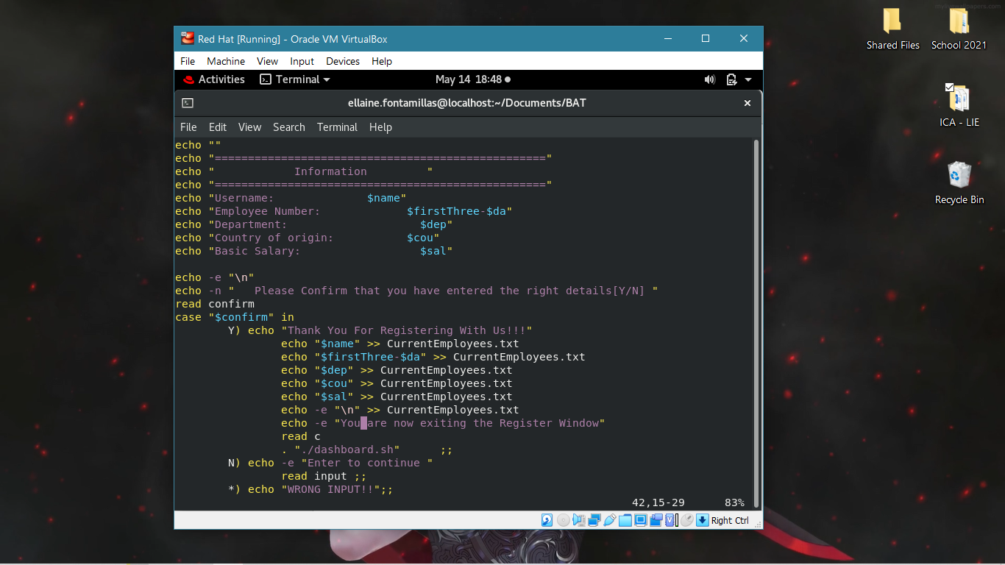

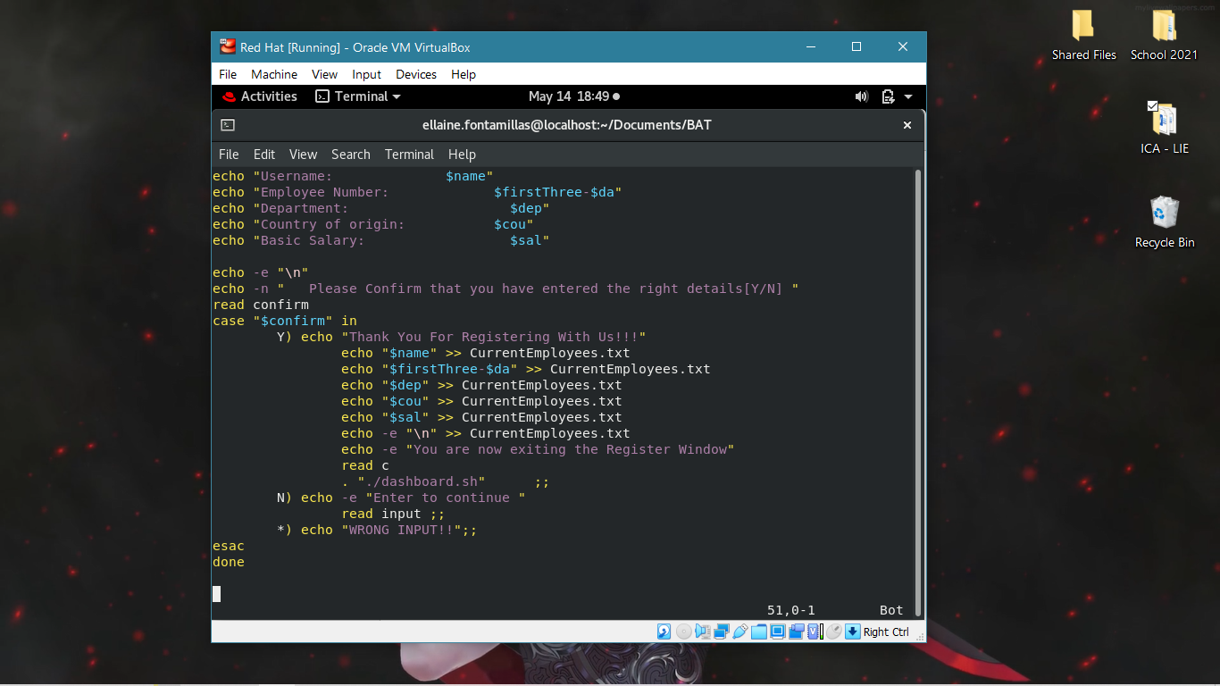

1. Creating the retrieve sh file

This is the **retrieve.sh** file

* It starts off with **clear** to clear the menu and show the **SEARCH WINDOW** instead.
* The *search window* will ask for which **category** the user is looking for
* This category is used as **search** **variable**
* And it will be used in a **case statement** to be identified
* If the category exists, then it will **prompt** the **user** to **Enter** the **specific record** they are looking for
* Their **input** will be **placed** in their **variables**, e.g., *Employee name* for *$name*
* Then the *search window* is **cleared**
* All cases use **SEARCH RESULTS** as a header after
* Using a *customized* **grep** for each it will display the record

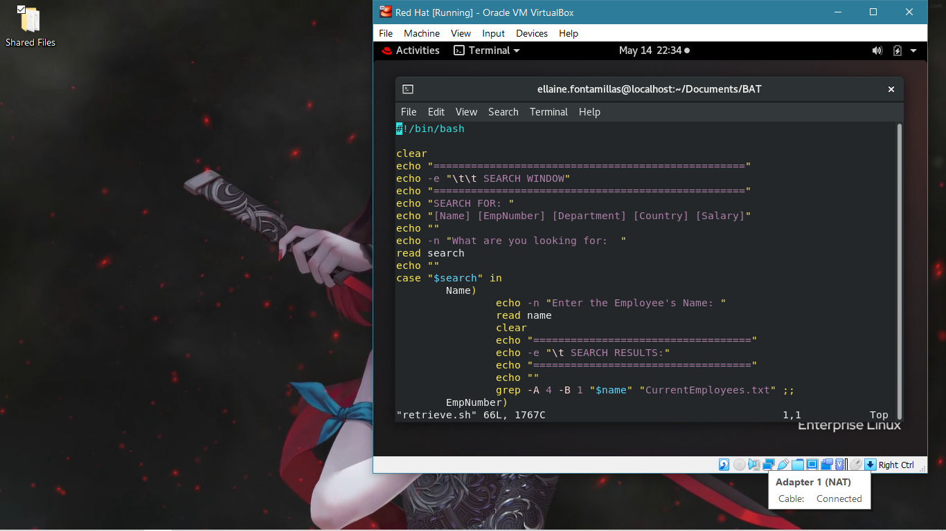

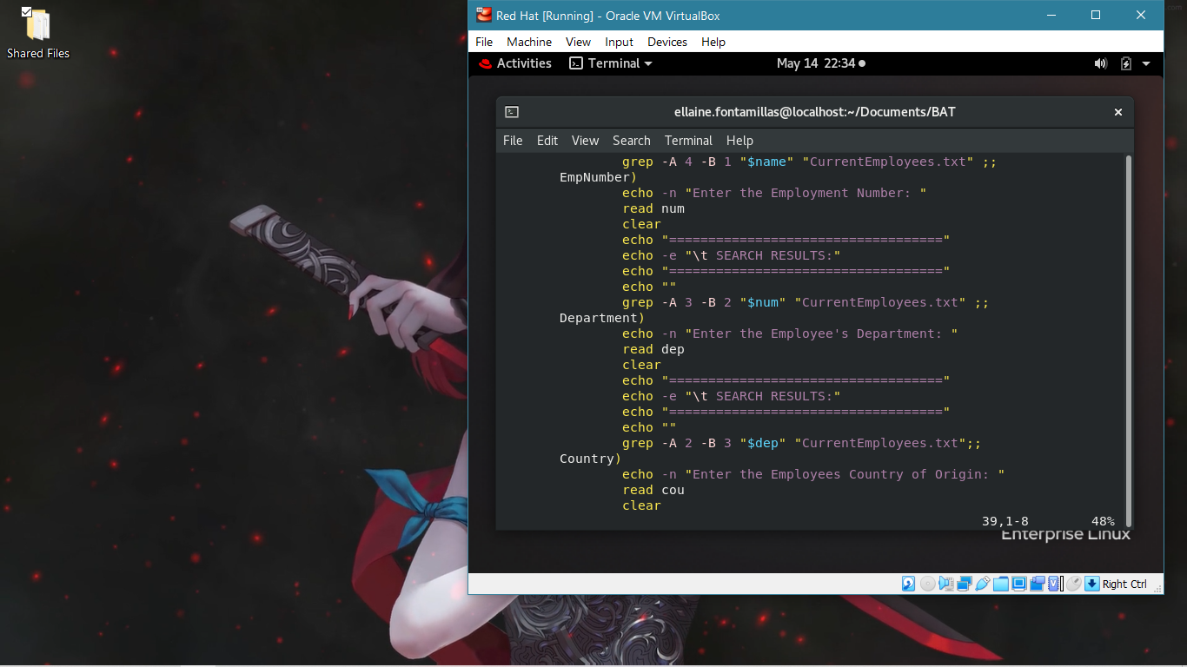

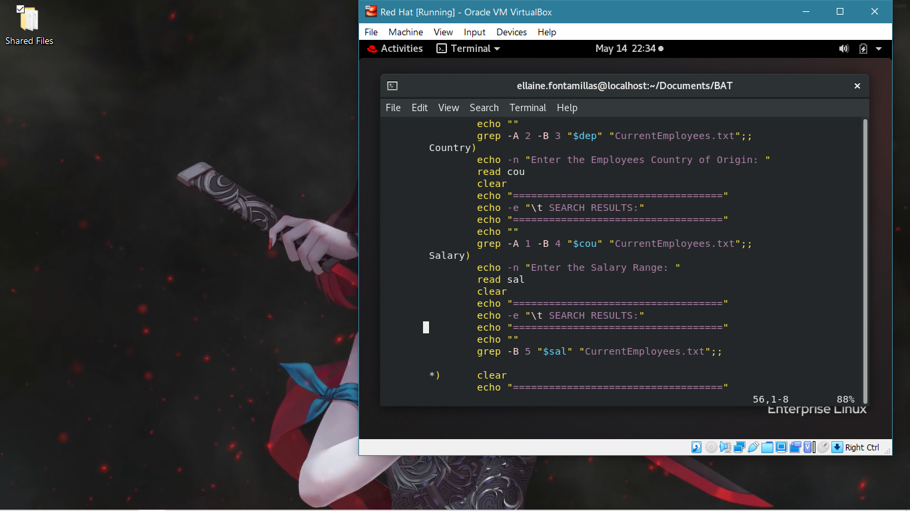

The grep syntax:

grep -A n -B n “variable” “file”

where:

* -A is Lines After
* -B is Lines Before
* n is number for lines

For Name:

It uses

grep -A 4 -B 1 “$name” “CurrentEmployees.txt”

**This means:**

* it will use **CurrentEmployees.txt** file where the records are saved
* There it will **look** for the **line** containing the **word** **searched**
* It will **display 4** **lines** after the searched words (as written in the txt file) hence:

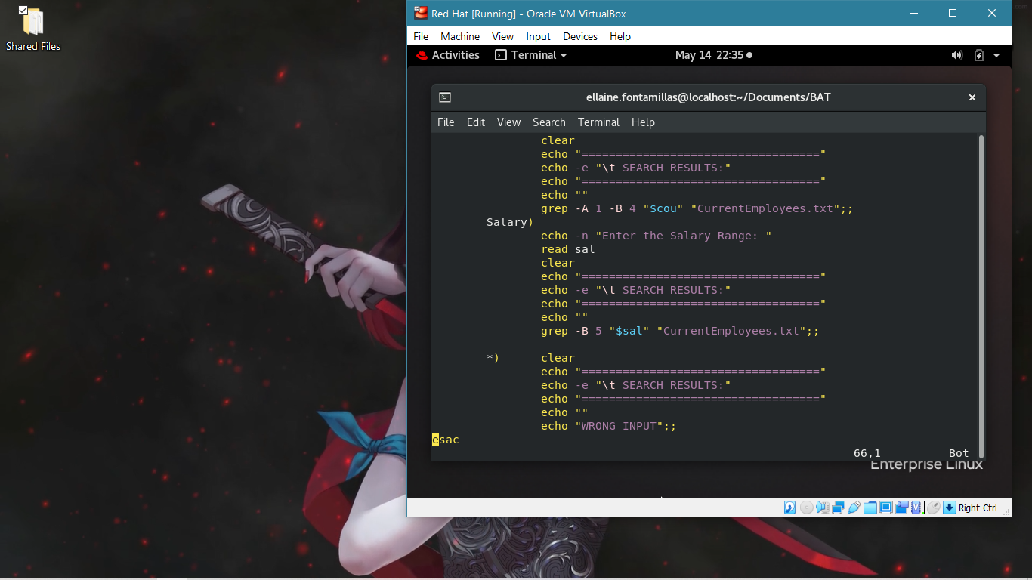

[grep -A 4] Four lines after.

* To include the searched line and not only the lines after, I used -B meaning Before the four lines.

Similar to this, I customized the arguments and the integers for each category:

-A 4 -B 1 | -A 3 -B 2

-A 2 -B 3 | -A 1 -B 4 | -B 5

**More explanation:**

It is important to know that the **Current Employees txt file** is where the original records are saved.

They are saved in a neat manner following their respective categories. All-in-all, they are displayed as 5 lines per record. We use the mentioned grep arguments to take account these lines and how they will be printed when being searched up.

1. 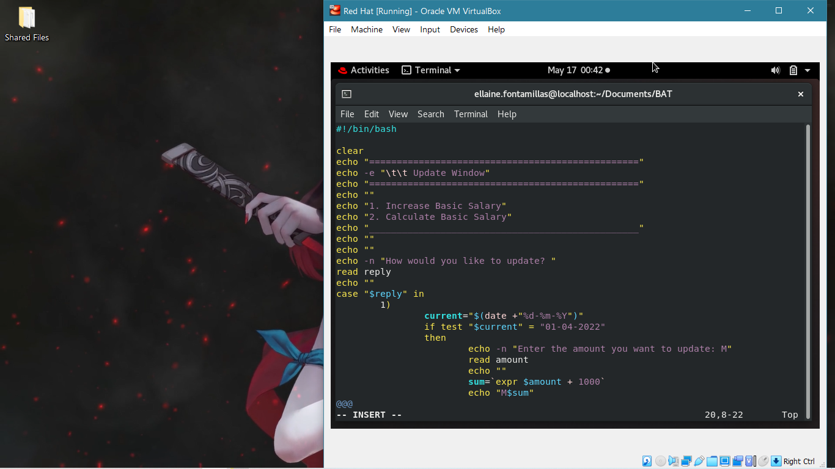Creating the update sh file

This is the **update.sh** file

It clears the previous contents on the screen to show the **update Window**

The user can choose to update by:

1. Increasing Basic Salary
2. Calculating Basic Salary/Cheque Bonus

Using case statement, option one **checks** first if the date is **April 1st**. If **true**, then it will ask the user to enter the **amount to update**

Using **$sum** we add the **M1000** **increase**

It is displayed, then a **sed** command is used to **identify** for the amount in **CurrentEmployees.txt**

Then it will notify the user of the updation

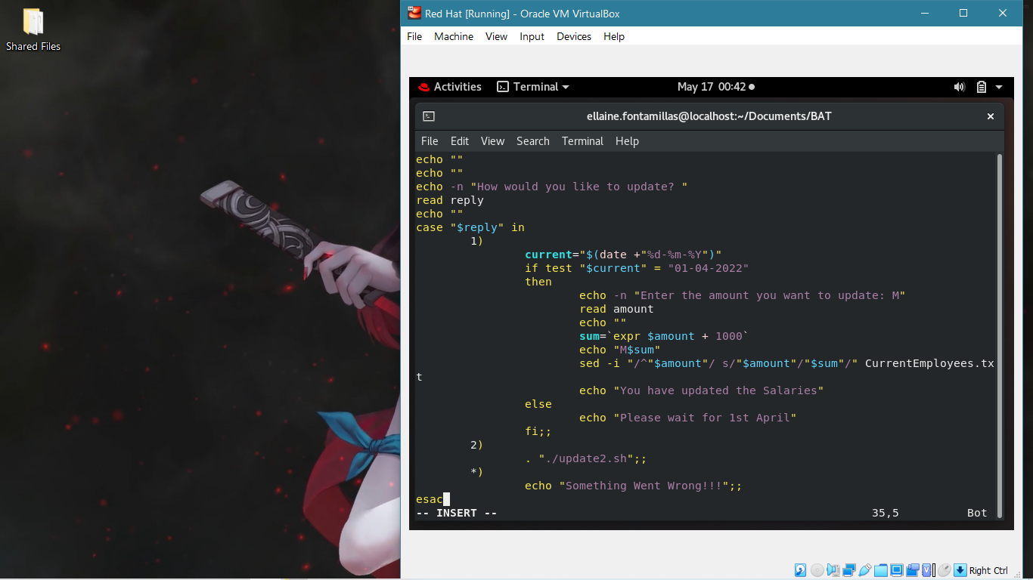

Breaking down the sed -i command

sed -i “/^”$amount”/ s/”$amount”/”$sum”/” CurrentEmployees.txt

|  |  |
| --- | --- |
| **sed -i** | It means to edit and overwrite the file |
| **/^”$amount”/** | This is the amount being looked for and the original data in the file |
| **/ s/** | This means substitution |
| **/”$amount”/”$sum”/”** | This is means from $amount to $sum |
| **CurrentEmployees.txt** | This is the file to be checked and overwritten |

If the date is not valid, then it will Notify the user to wait for the appropriate time

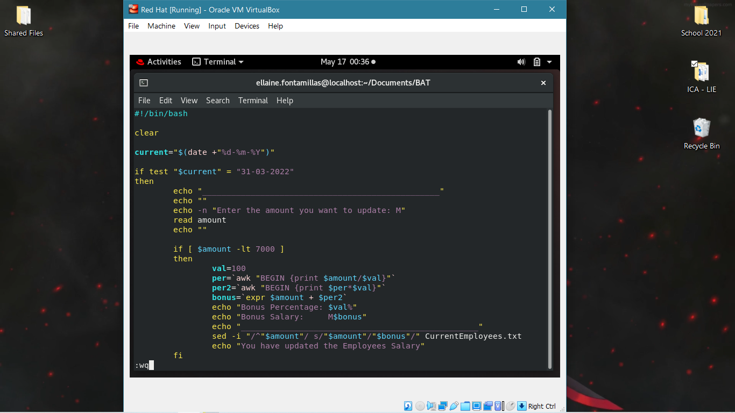The second option is **. ”./update2.sh”** which will redirect to update2 file. Then the default option Just notifies the user that they select an invalid input.

This is the **update2.sh** file

It starts by clearing the previous contents on the screen

Followed by testing for the **current date.**

If the date is **a day before** the **1st of April**, then the user is **allowed to calculate** the **bonus** salary for the employee.

If not, they will be made aware to wait until it is.

It will ask the user which amount to update

An **if statement** is used to check the salary range:

1. If amount is less than ( -**lt** ) **R7000** then,

* It creates the variable to store 100
* Another variable **per** to store a function using **awk** to calculate amount divided by 100
* Again, **per2** for function to use *per* and multiply it by 100
* Then bonus to add the **percentage** to the original amount

It will be displayed

Then again using **sed -i,** we overwrite CurrentEmployees.txt to **keep the changes**

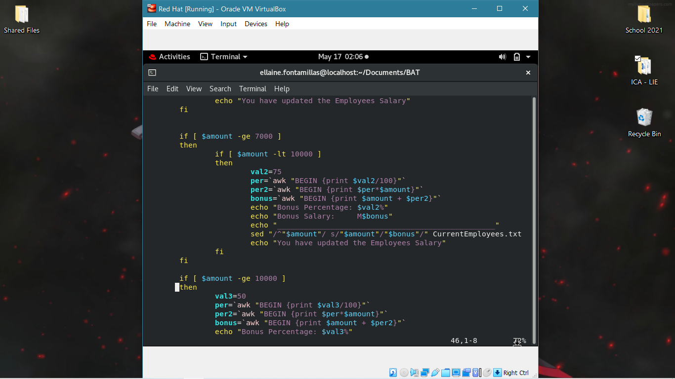

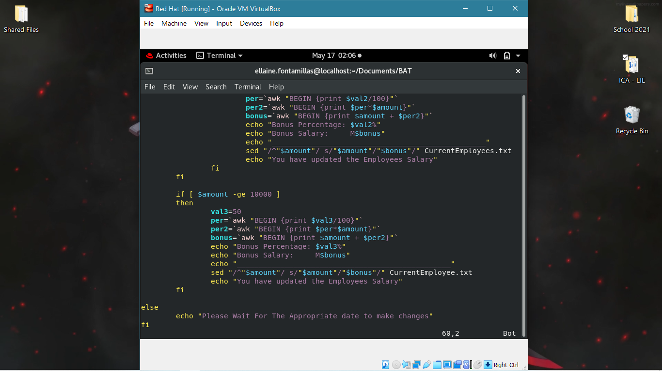

The other if functions test:

* If amount **Greater than** and **equal to R7000** but **less than R10000**
* If amount is *Greater than* **R10000**

The calculations for these two makes **val** as their **respective percentages,** and then **divided by 100** to get a **floating number** using **awk**. It will be: **0.75%** and **0.5%**, which will be multiplying the amounts to **get the percentage of that amount**, and lastly it will be **added** to the amount to get the **bonus**.

**Sed -i** is used to **overwrite** the **changes** to the **original** **file** and finally notify the user of the changes.

1. Creating the remove sh file

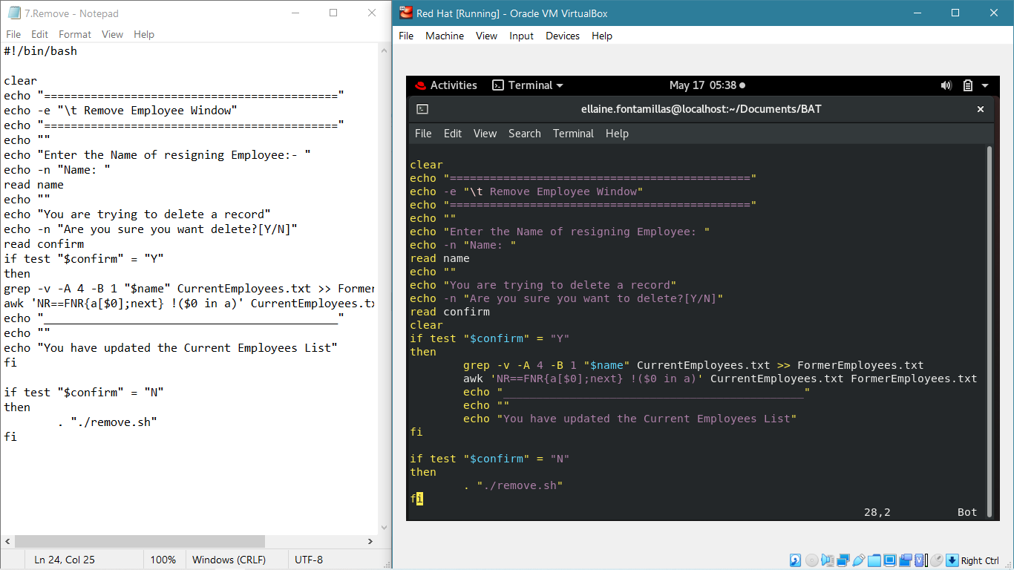

This is the **remove sh** file. It starts off by clearing, then having a header – **Remove Employee Window**

It will ask the user to **Enter Name** of **resigning employee**, which will be read. Using **grep** command, it will **search** for the name in the **CurrentEmployees.txt** file and **append** it **to** the **FormerEmployees.txt** file. Using **awk** command, it will **then** **delete** the **common lines** in *CurrentEmployees.txt* that was **moved** to FormerEmployees.txt. Lastly, the user is informed of the changes

Breaking down the **awk** command

awk ‘NR==FNR{a[$0];next} !($0 in a)’ CurrentEmployees.txt FormerEmployees.txt

|  |  |
| --- | --- |
| **NR==FNR{a[$0]; next}** | This stand for an associative array for storing the first file |
| **NR==FNR** | This stand for counters of the current file line and the global line counter |
| **a[$0]** | This is adding current line to associative array |
| **!($0 in a)** | This stand for the next file, where **in** is checking whether the current line is occupied and then removes it (! - negates) |

If the date is not valid, then it will Notify the user to wait for the appropriate time

1. 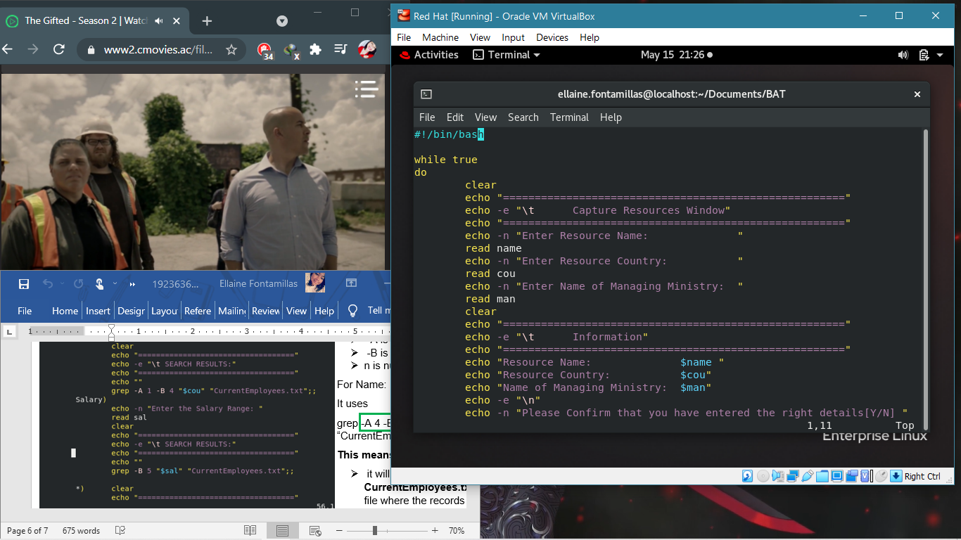Creating the capturing sh file

This is the **capturing.sh** file

* I used a loop to display a **window** where the user will enter the appropriate information
* It will **clear** the **upper window**. After **entering** the **information**, a window will **display** what the user **entered**.
* A case is used to prompt the user to confirm
* If they **confirmed** that it is **correct,** then the information will be entered in Resources.txt

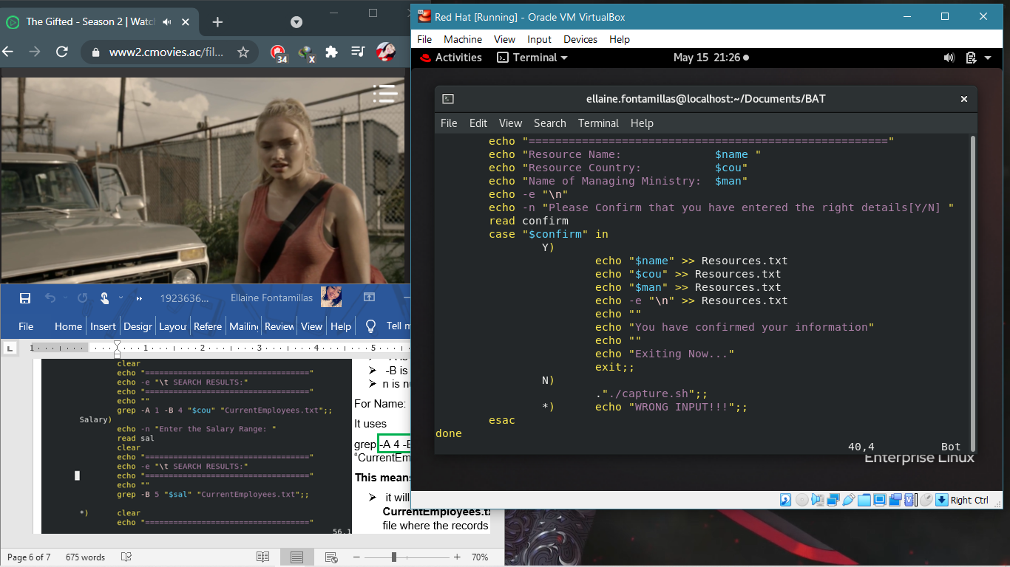

To exit out of the loop after confirming, I used **exit;;** Which is the only way to get out of the loop, as it did not read when I used **.”./dashboard.sh”** first.

The other case option **N)** uses **.”./capture.sh”** to start the shell script again, and the last case option just notifies the user they entered the wrong input.

**Outputs:**

**Registering**

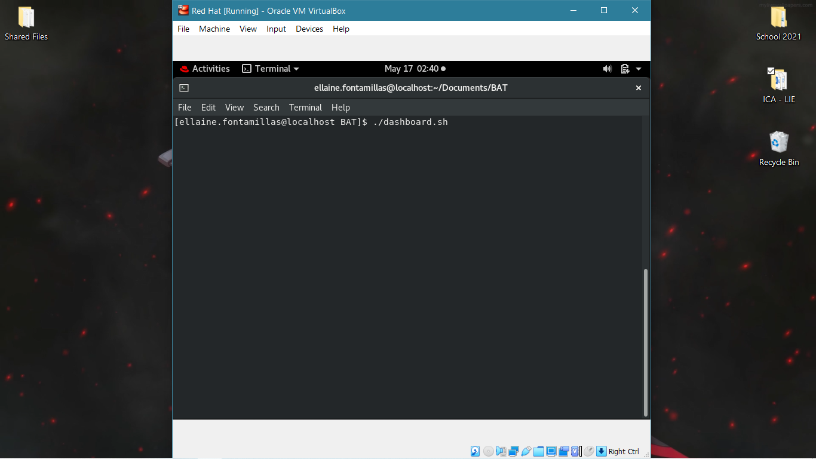

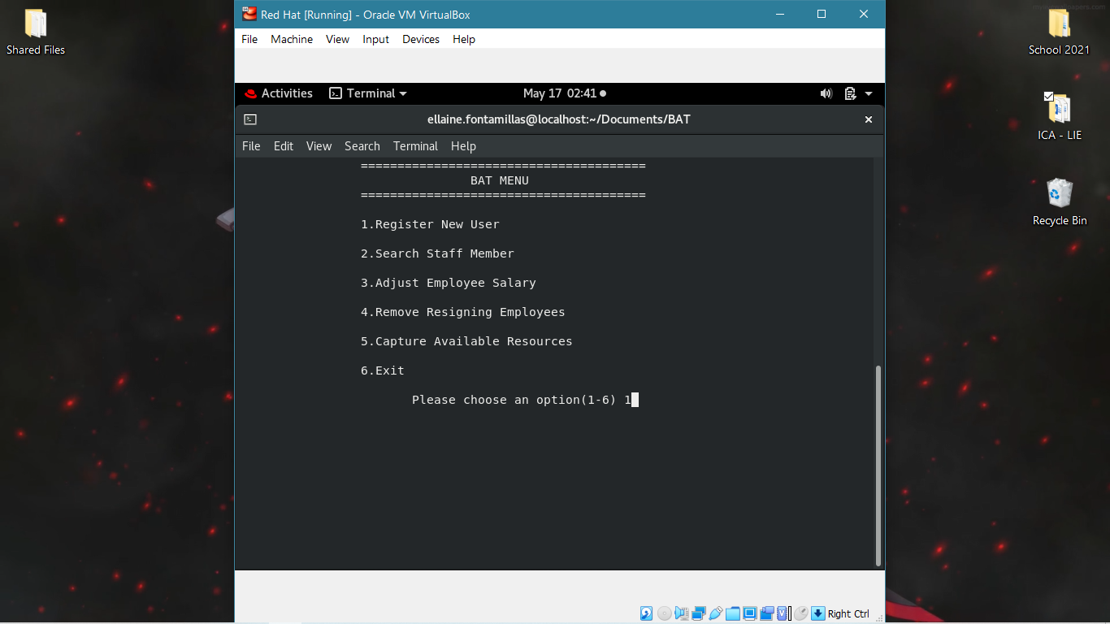

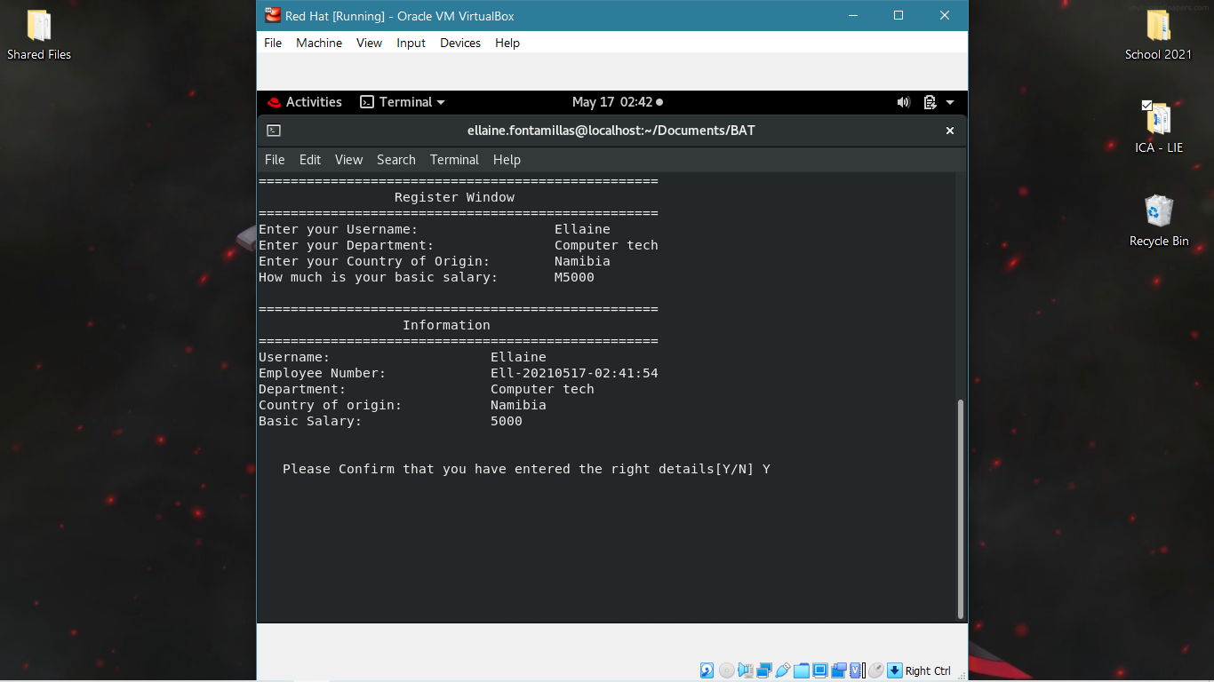

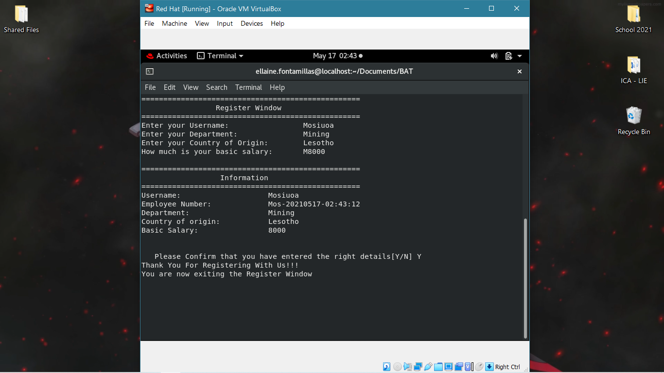

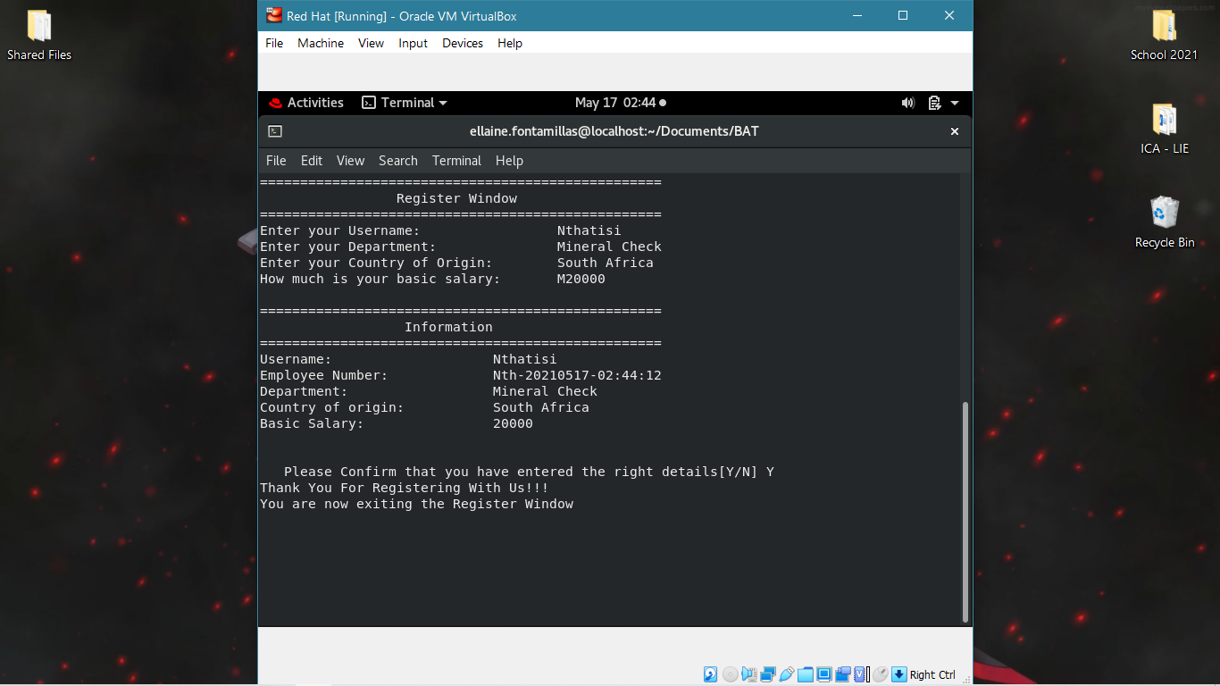

**CurrentEmployees.txt**

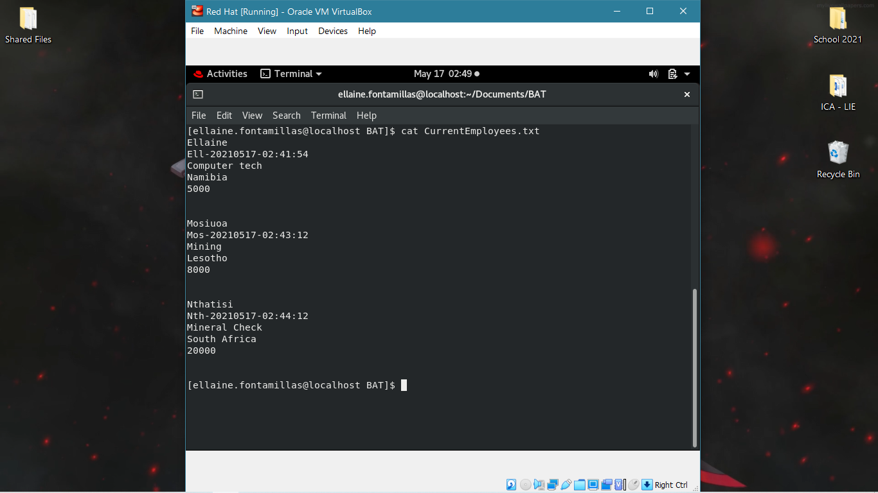

**Retrieve**

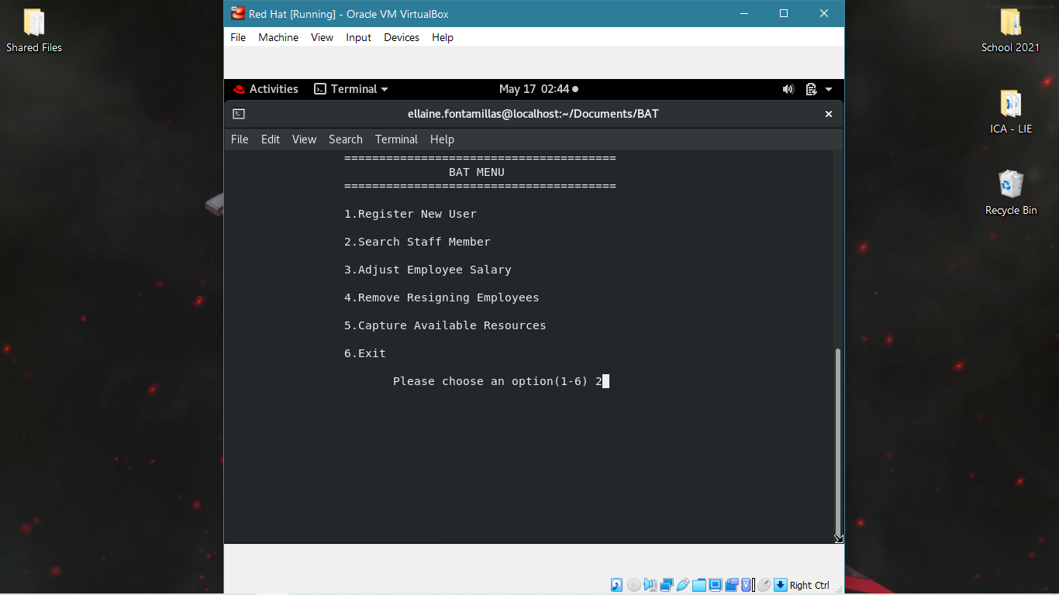

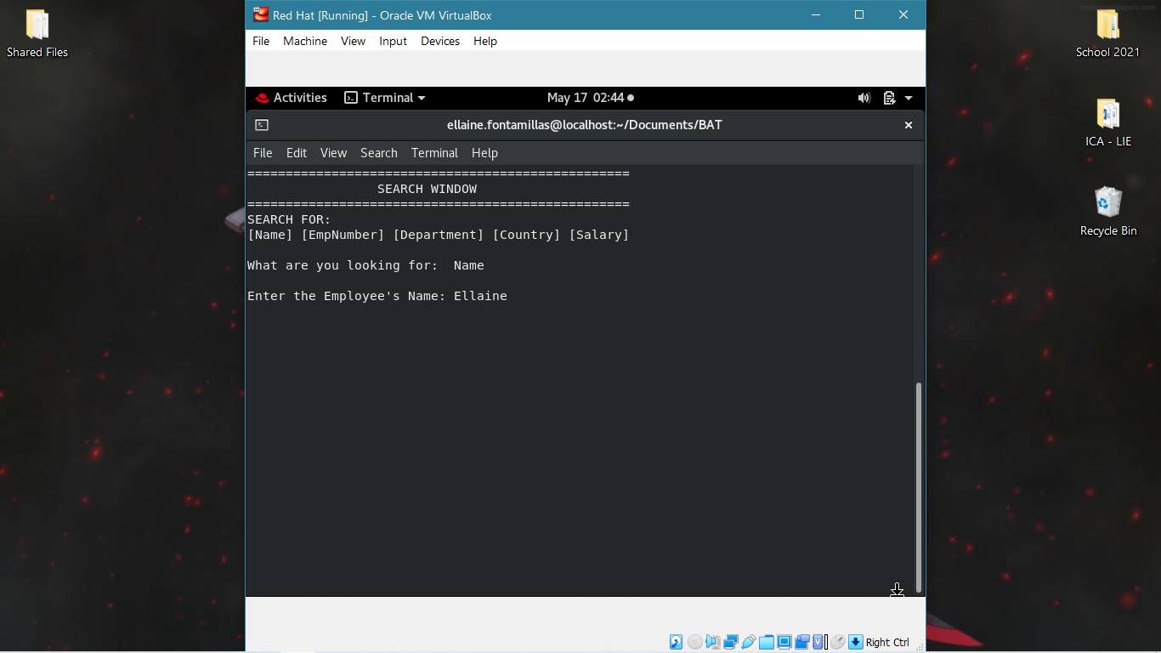

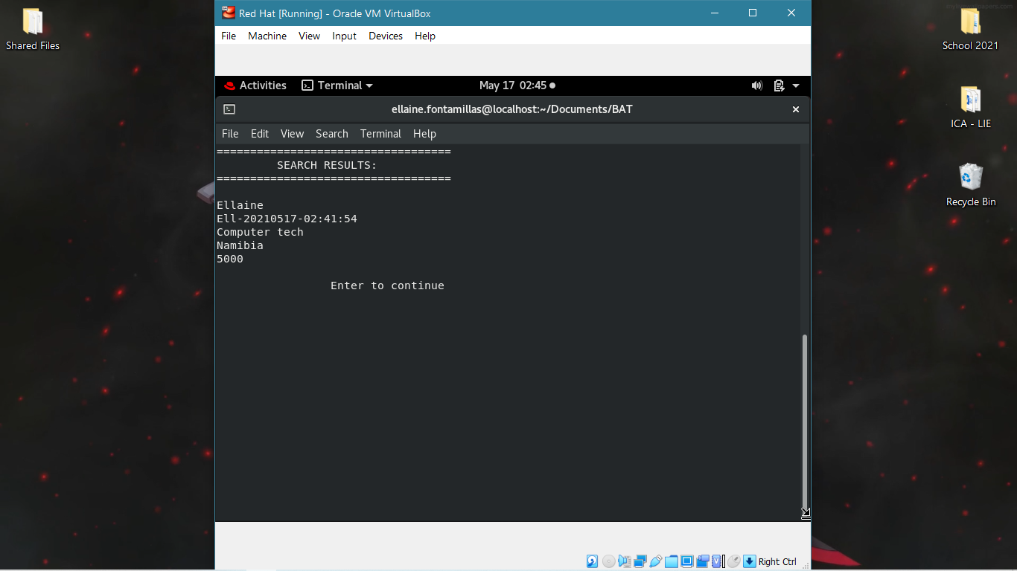

**Update**

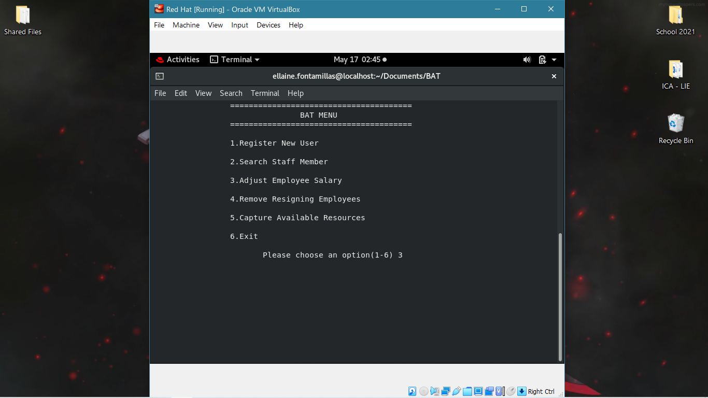

Due to the validating of the check, the user cannot do any changes through this option, since the dates to update are 1st April and 31st March

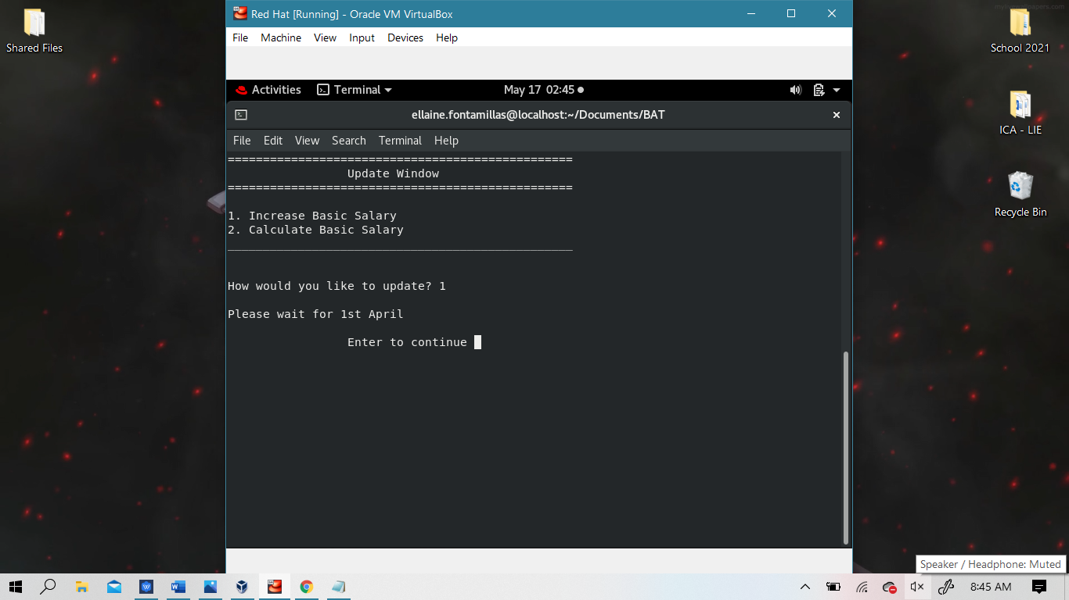

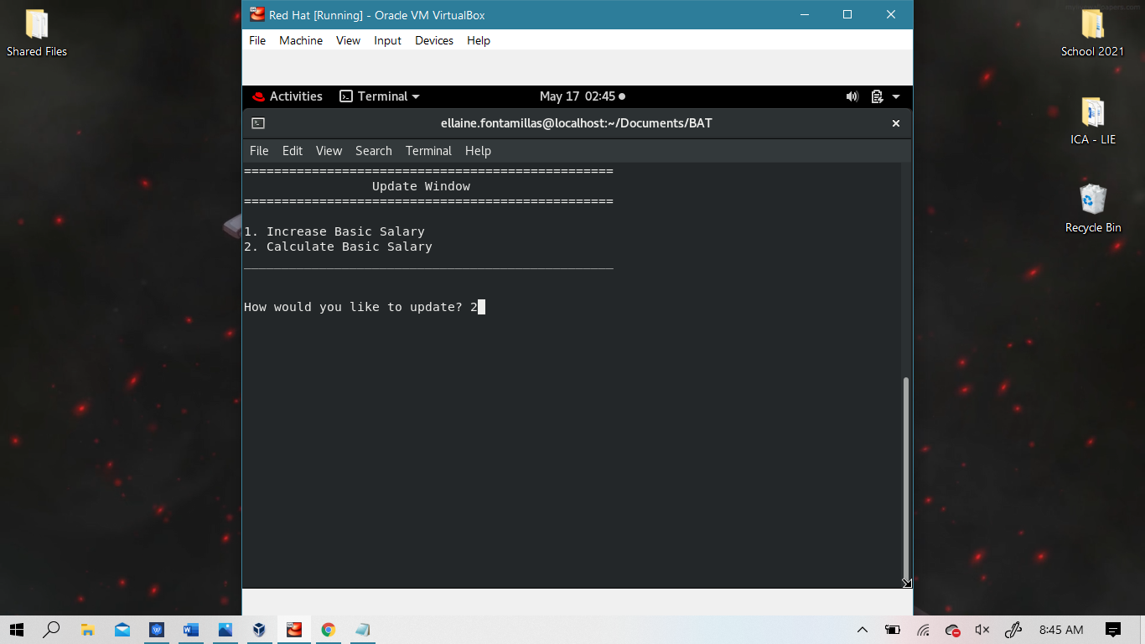

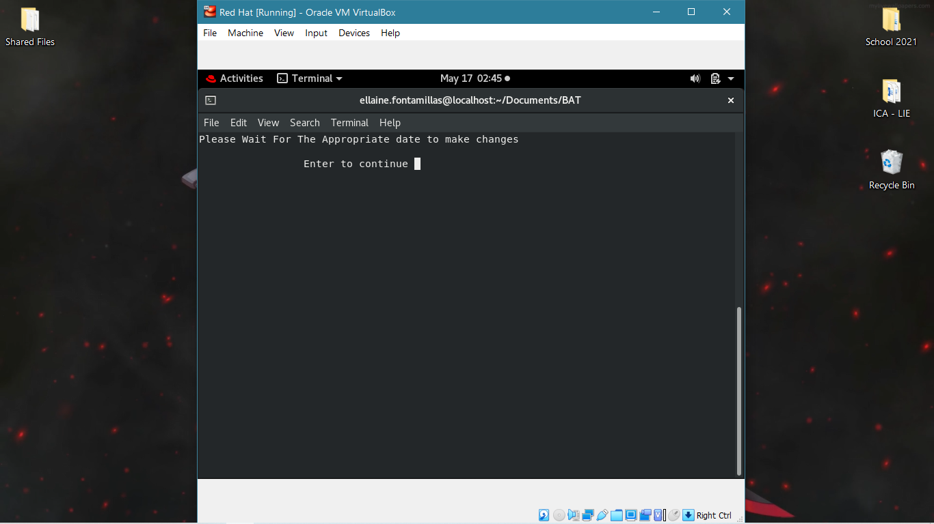

If the dates were valid, then we can use these options:

**Option** **1 Increase Basic Salary**

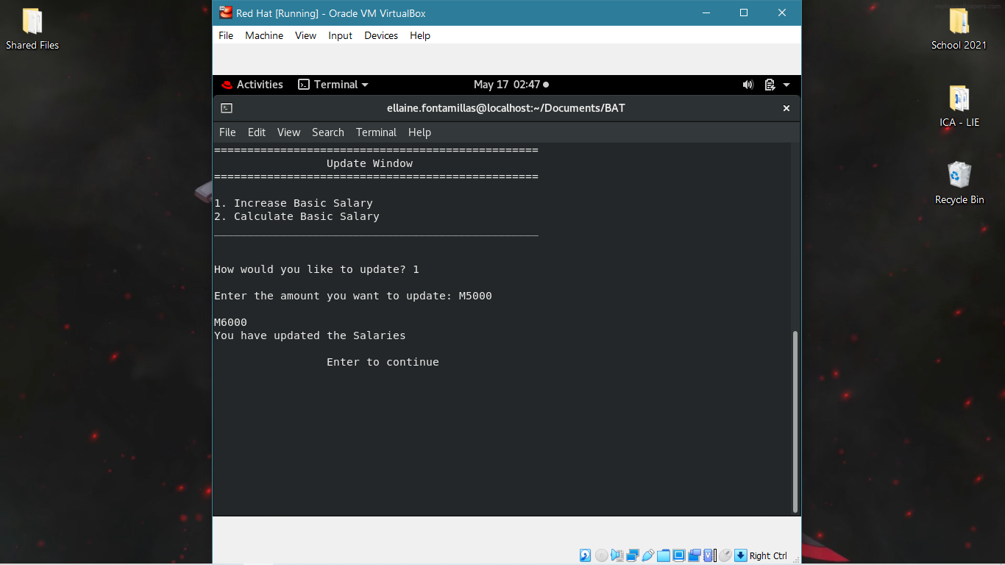

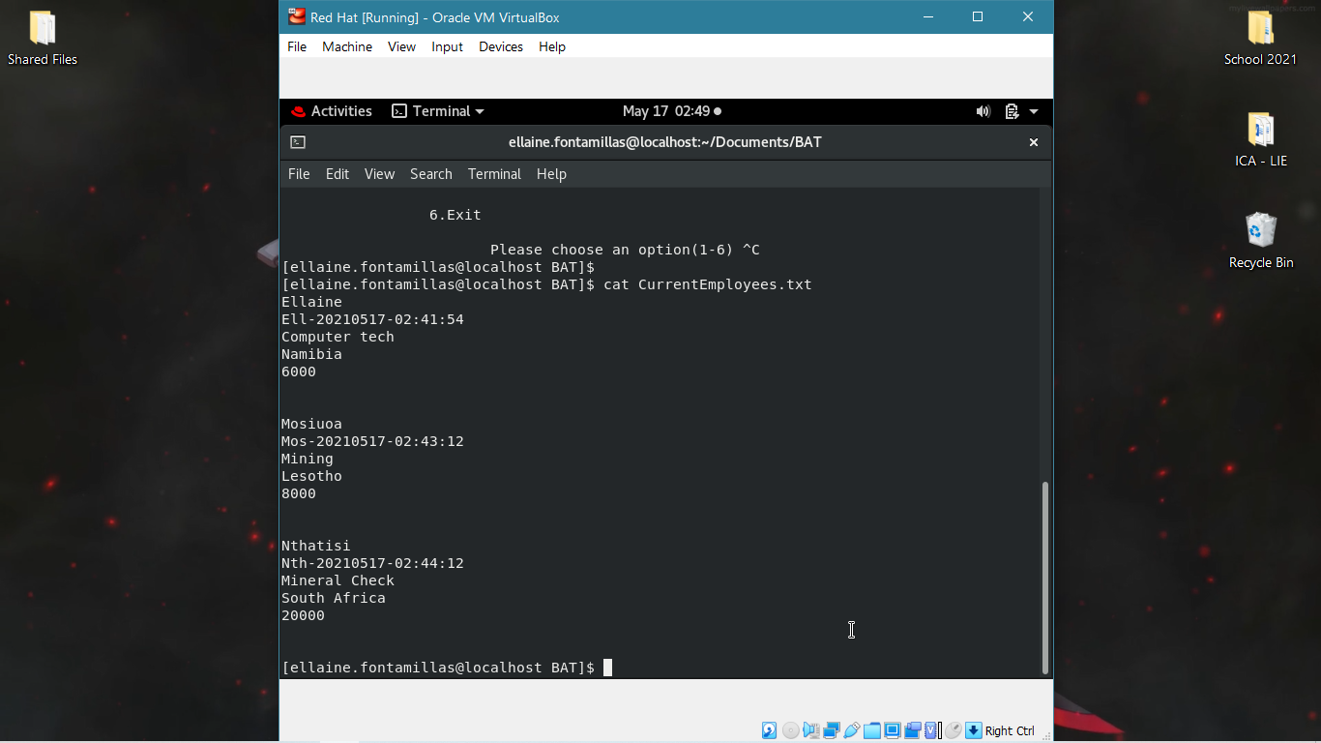

**Option 2 to calculate**

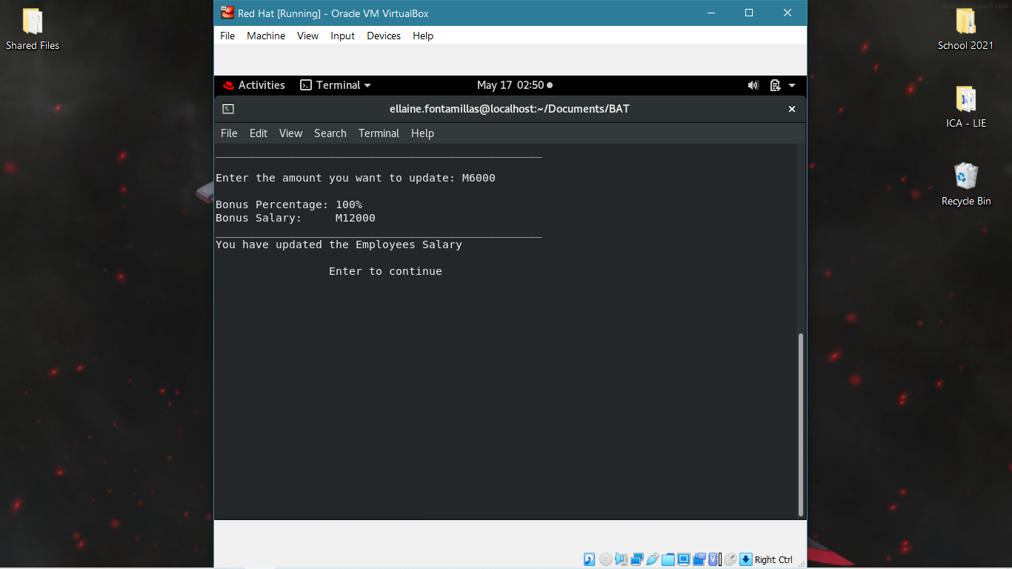

M6000 is **less than** M7000 so it gets 100% bonus

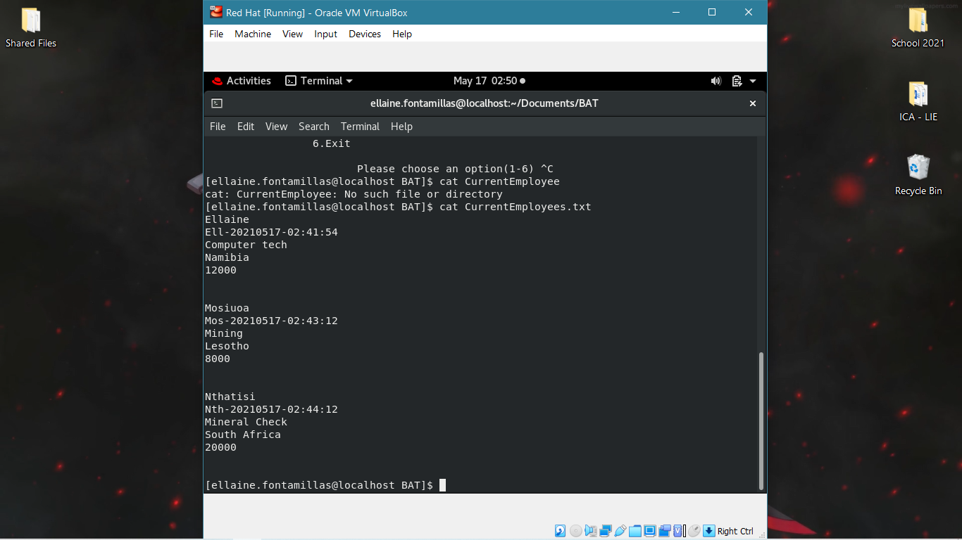

From **M6000** to **M12000**

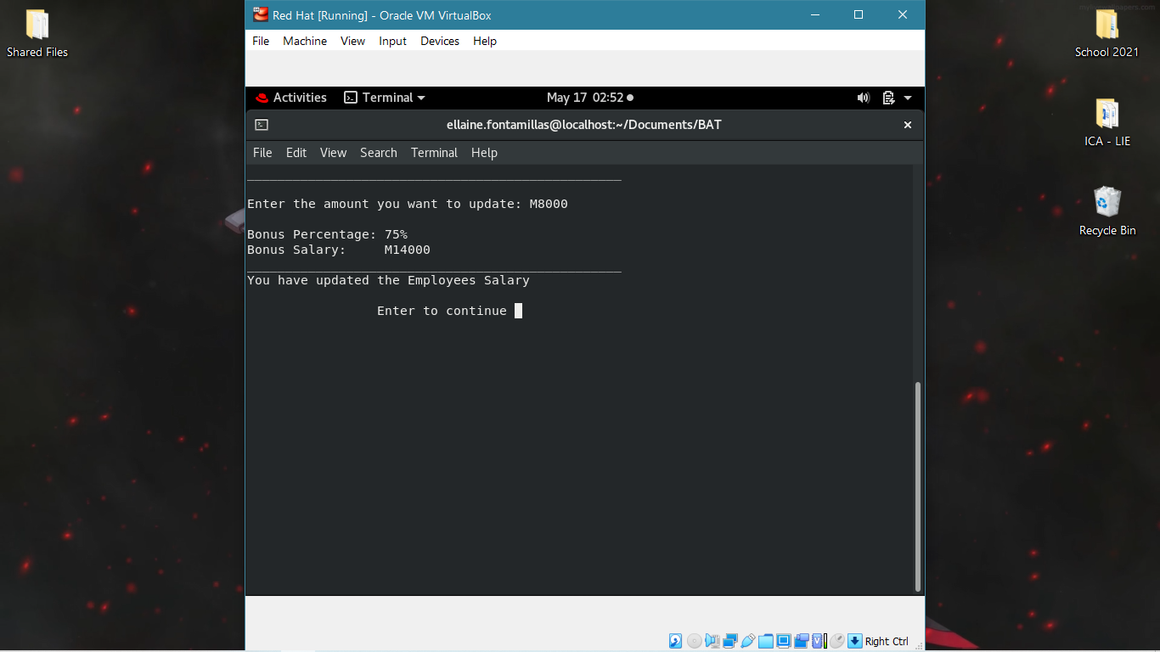

M8000 is **greater than** M7000 but **less than** R10000 so it gets 75% bonus

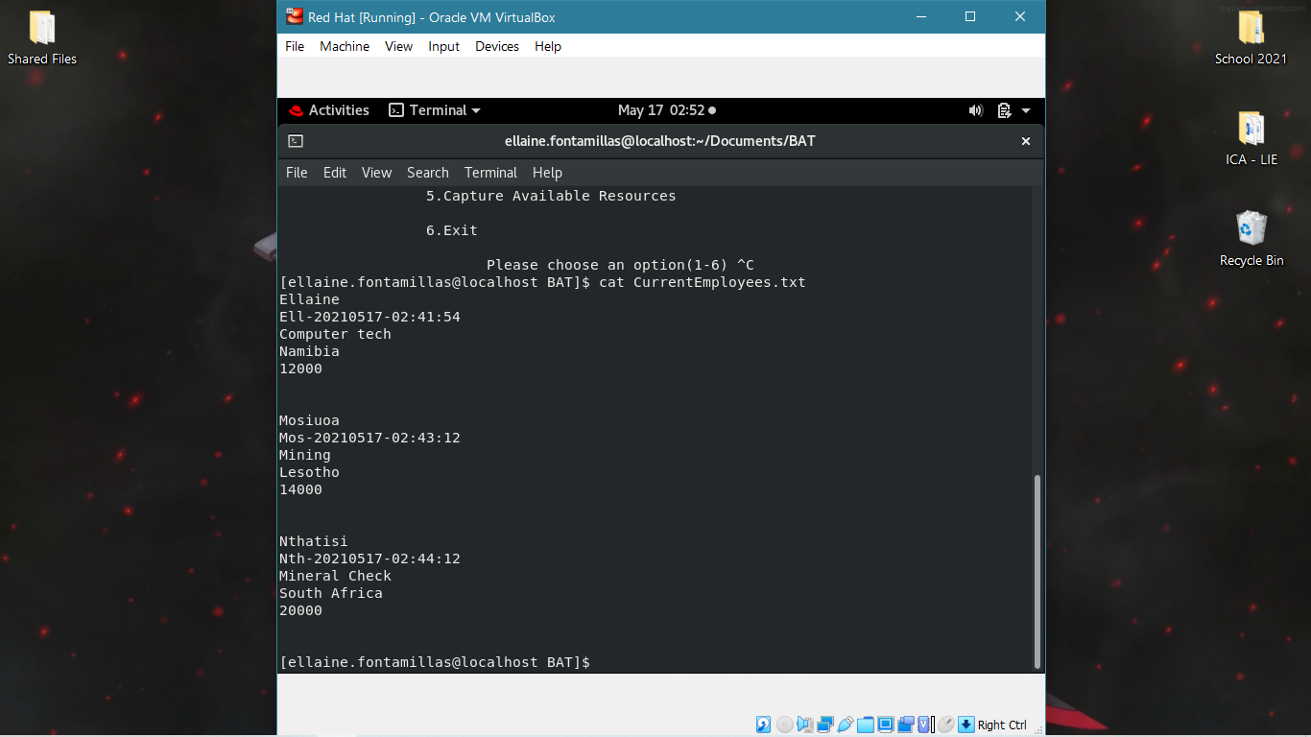

From **M8000** to **M14000**

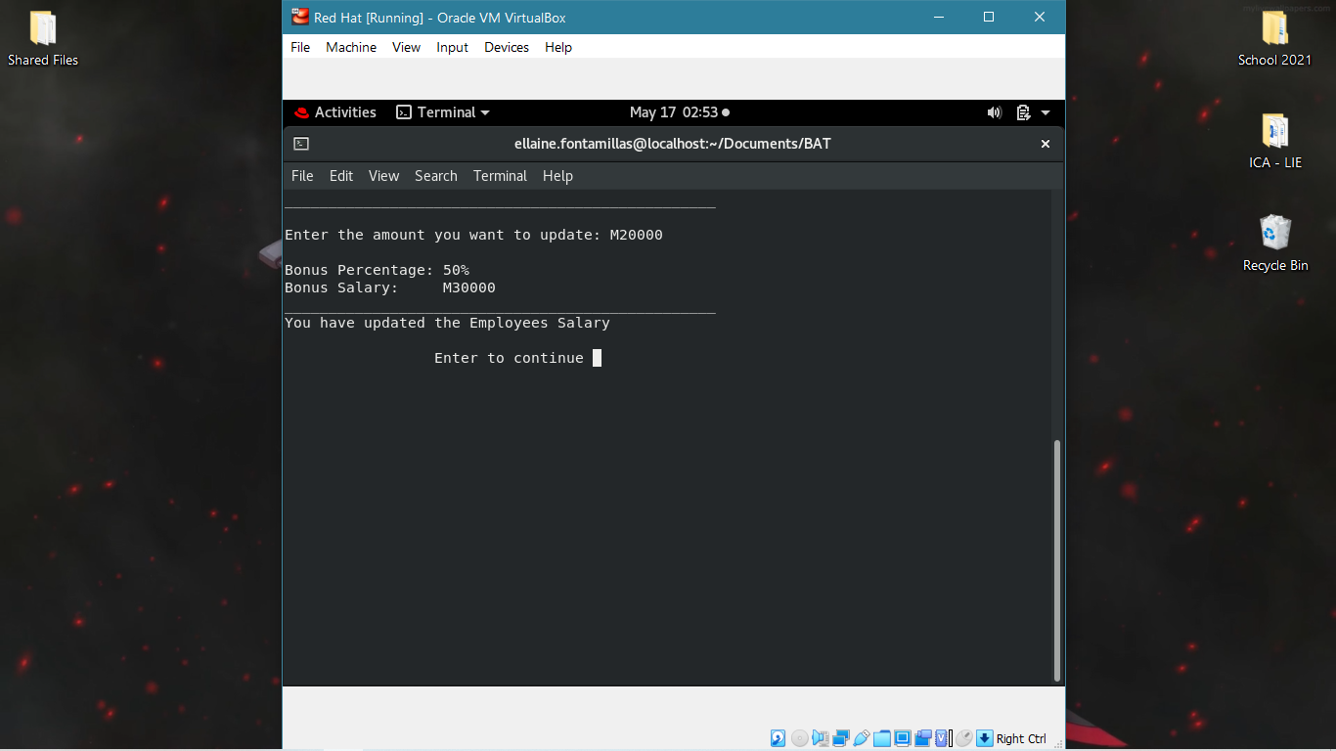

M20000 is **greater than** M10000 so it gets 50% bonus

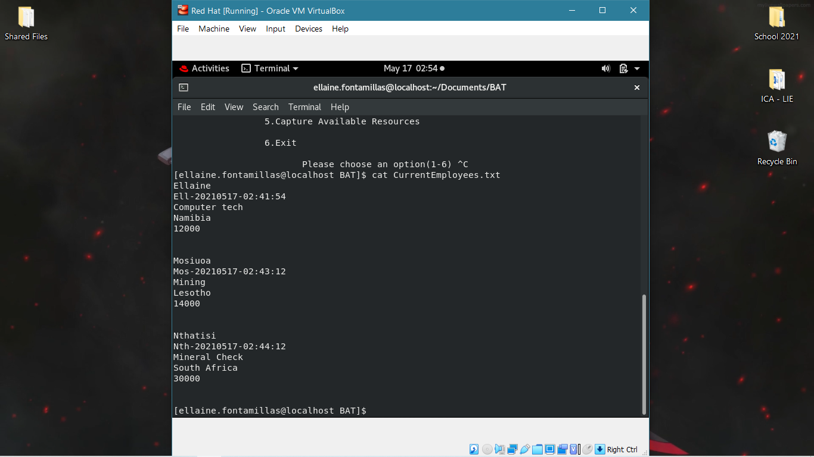

From **M20000** to **M30000**

**Remove**

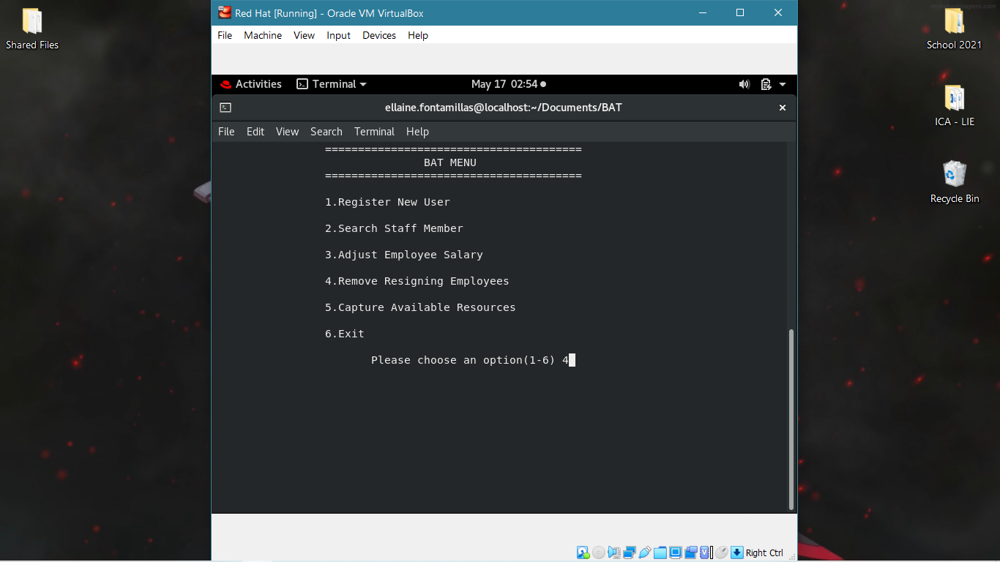

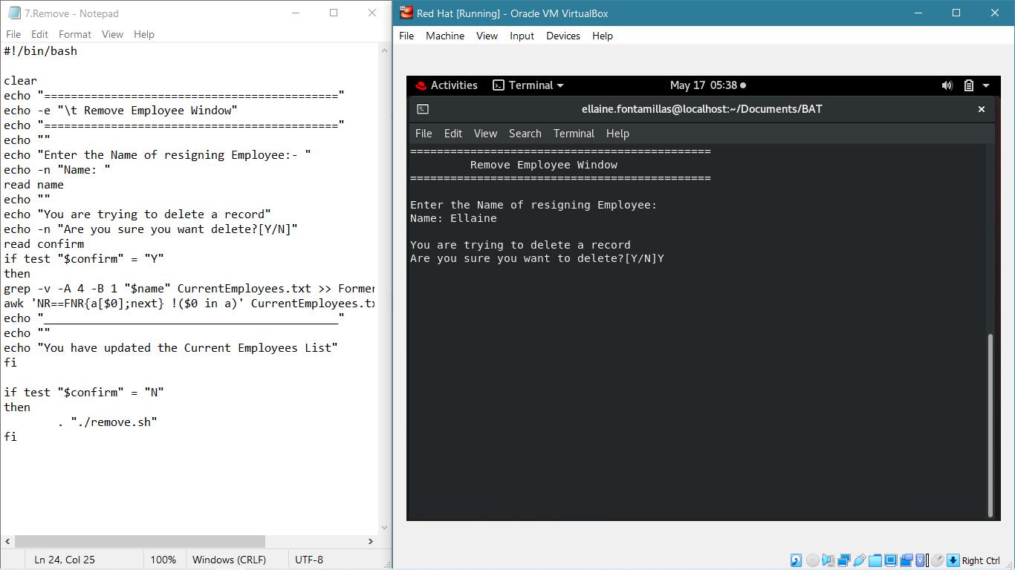

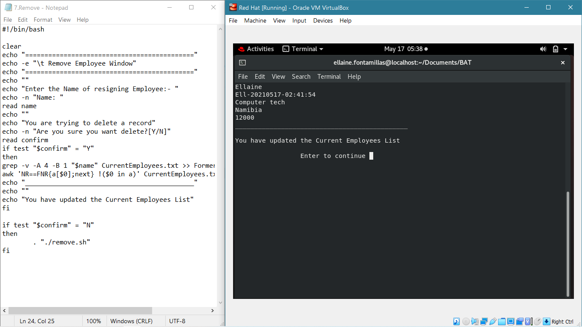

**CurrentEmployees.txt AND FormerEmployees.txt**

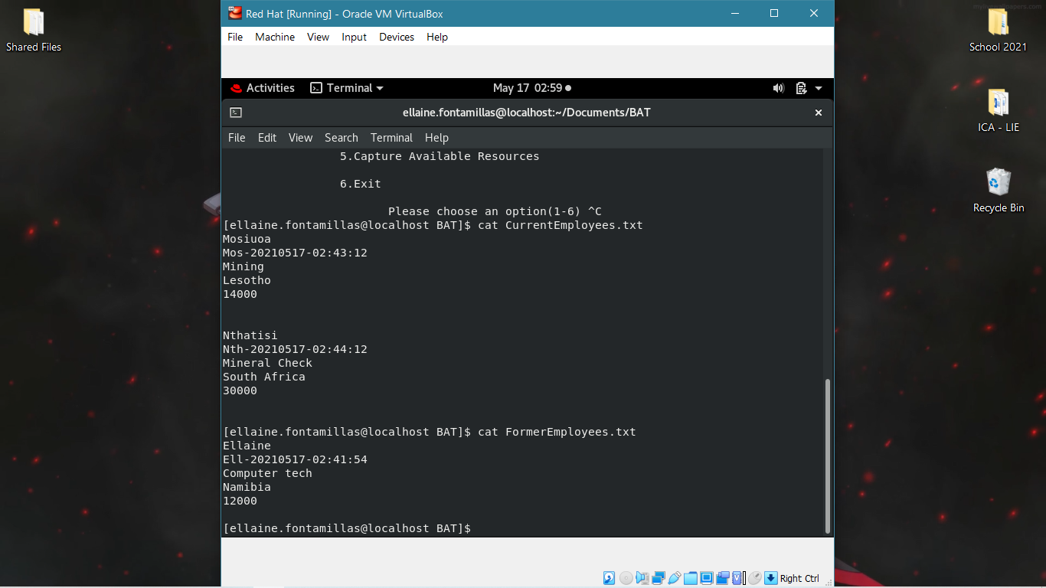

**Capture**

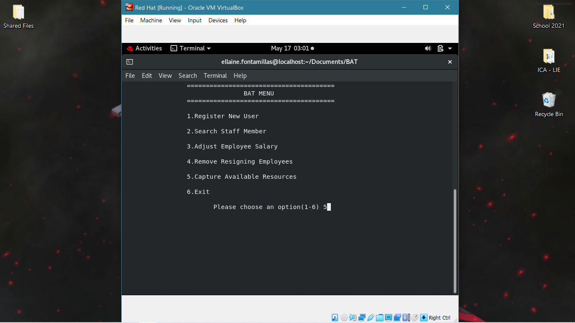

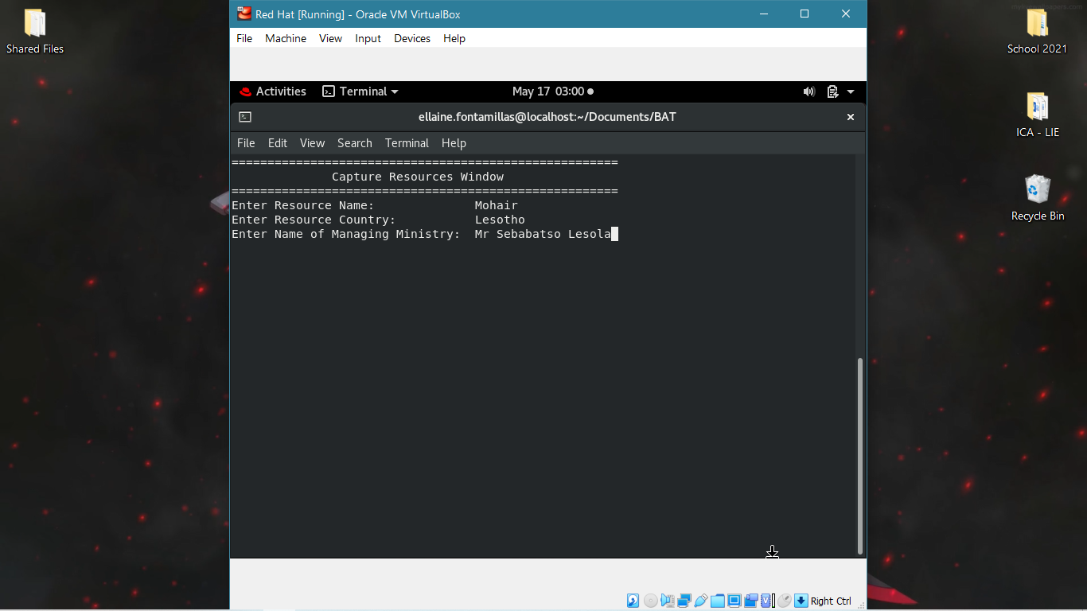

Capturing the information

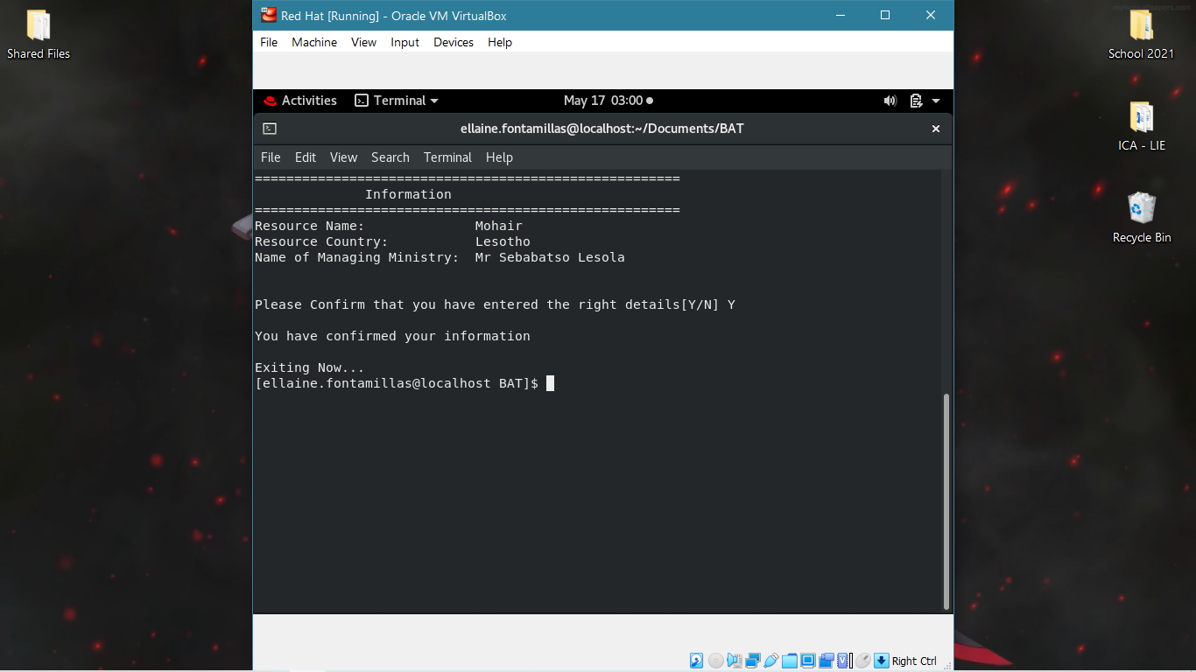

Displaying and confirming the details

**Resources.txt**

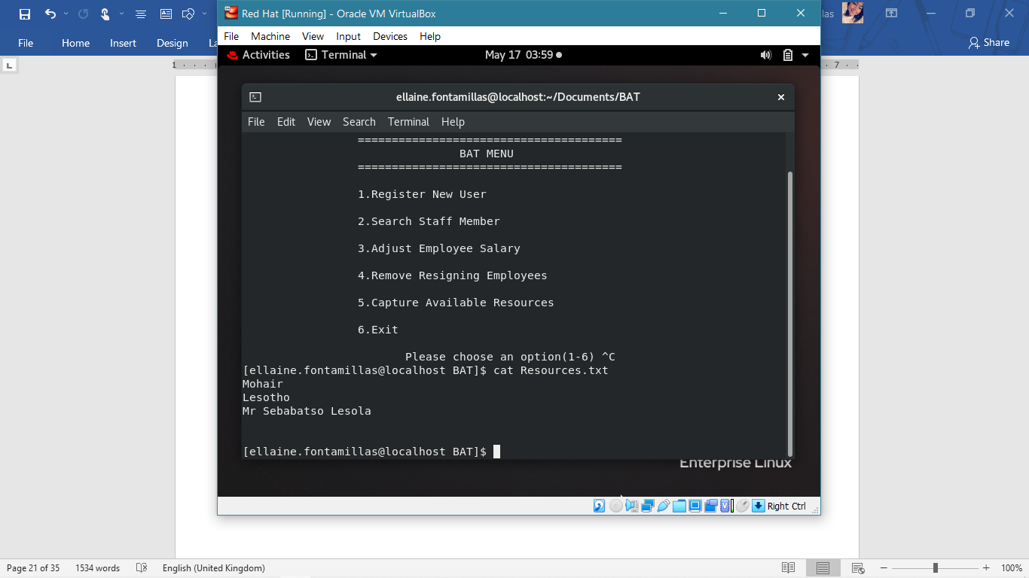

**Exit**

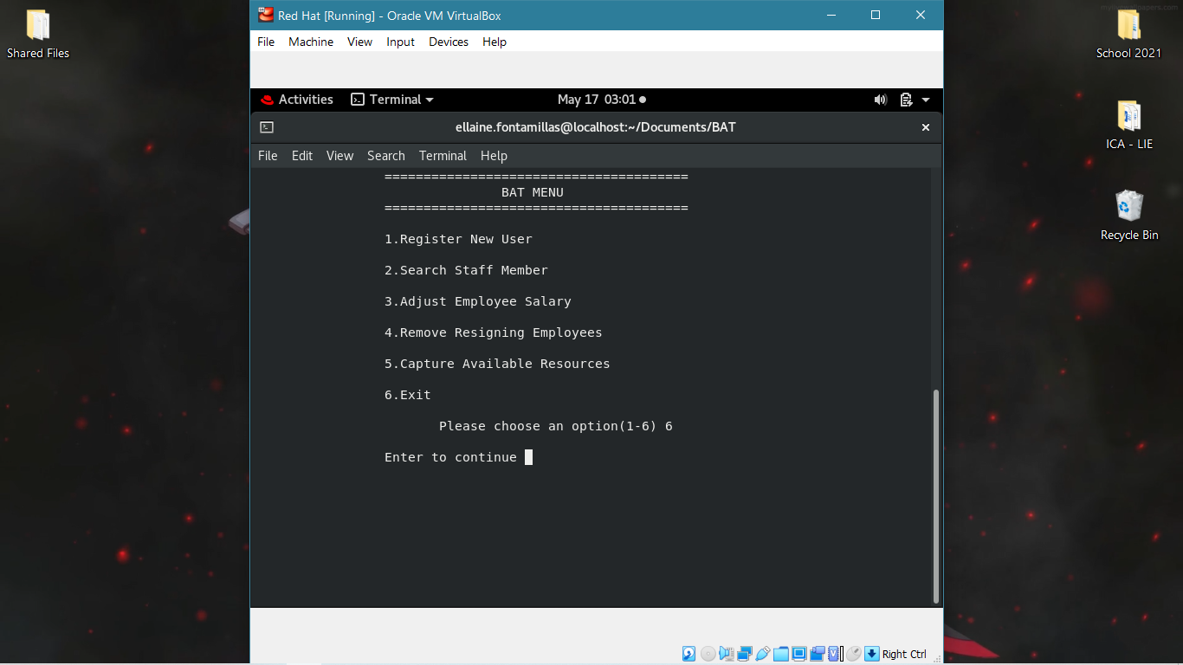

**Conclusion**

The project was fairly easy to do with the guidelines and the generous time given to research. Although some errors were unnerving, after much studying and thorough look in materials through **School Materials, YouTube, Forums**, **etc**. the solutions managed to reveal themselves.

**Reference**

A?, H., Paul, T. and BAD, C., 2021. *How to remove the lines which appear on file B from another file A?*. [online] Stack Overflow. Available at: <https://stackoverflow.com/questions/4366533/how-to-remove-the-lines-which-appear-on-file-b-from-another-file-a> [Accessed 17 May 2021].

Google.com. 2021. *Before you continue to Google Search*. [online] Available at: <https://www.google.com/search?q=command+that+checks+if+contents+of+file1+match+file2+and+delete+only+the+lines+in+file1+that+copies+file2&oq=command+that+checks+if+contents+of+file1+match+file2+and+delete+only+the+lines+in+file1+that+copies+file2&aqs=chrome..69i57.41905j0j4&sourceid=chrome&ie=UTF-8> [Accessed 17 May 2021].

unix, H. and Pagode, M., 2021. *How can I replace a word at a specific line in a file in unix*. [online] Stack Overflow. Available at: <https://stackoverflow.com/questions/15646800/how-can-i-replace-a-word-at-a-specific-line-in-a-file-in-unix> [Accessed 17 May 2021].

Google.com. 2021. *Before you continue to Google Search*. [online] Available at: <https://www.google.com/search?q=sed+command+arguments+script&oq=sed+command+arguments+script&aqs=chrome..69i57.11192j0j4&sourceid=chrome&ie=UTF-8> [Accessed 17 May 2021].

Google.com. 2021. *Before you continue to Google Search*. [online] Available at: <https://www.google.com/search?q=can+I+test+if+for+date+of+current+day+is+valid+in+shell+script%3F&sxsrf=ALeKk00ATjxk50E-5mgDduxhJEi_evgjUA%3A1621204048470&ei=UJyhYOaUHNXexgPn8bOwCw&oq=can+I+test+if+for+date+of+current+day+is+valid+in+shell+script%3F&gs_lcp=Cgdnd3Mtd2l6EAM6BwgjELADECc6BwgAEEcQsAM6BAgjECc6BQgAEJECOggILhCxAxCDAToICAAQsQMQgwE6BAguEEM6AggAOgIILjoFCAAQyQM6CAghEBYQHRAeOgYIABAWEB46CQgAEMkDEBYQHjoECCEQFToFCCEQoAE6BwghEAoQoAE6BAghEApQ_cYCWJX8A2D9_QNoCnACeACAAcwFiAH02AGSARAwLjEuMjYuMTguMjAuOC4xmAEAoAEBqgEHZ3dzLXdpesgBCcABAQ&sclient=gws-wiz&ved=0ahUKEwjm_Krbn8_wAhVVr3EKHef4DLYQ4dUDCA4&uact=5> [Accessed 17 May 2021].

Google.com. 2021. *Before you continue to Google Search*. [online] Available at: <https://www.google.com/search?q=how+to+select+multiplt+lines+in+vi+script&oq=how+to+select+multiplt+lines+in+vi+script&aqs=chrome..69i57.16613j0j9&sourceid=chrome&ie=UTF-8> [Accessed 17 May 2021].

pattern, s., 2021. *sed multiline delete with pattern*. [online] Stack Overflow. Available at: <https://stackoverflow.com/questions/37680636/sed-multiline-delete-with-pattern> [Accessed 17 May 2021].

Shell-tips.com. 2021. [online] Available at: <https://www.shell-tips.com/bash/math-arithmetic-calculation/> [Accessed 17 May 2021].

Informatica, Oracle, Netezza, Unix, Hadoop Tutorials and Examples. 2021. *Unix Sed Command to Delete Lines in File - 15 Examples*. [online] Available at: <https://www.folkstalk.com/2013/03/sed-remove-lines-file-unix-examples.html> [Accessed 17 May 2021].

bash, R. and Morton, E., 2021. *Removing multiple block of lines of a text file in bash*. [online] Stack Overflow. Available at: <https://stackoverflow.com/questions/25227759/removing-multiple-block-of-lines-of-a-text-file-in-bash> [Accessed 17 May 2021].

found, D. and G, C., 2021. *Delete multiple lines from file when text is found*. [online] Ask Ubuntu. Available at: <https://askubuntu.com/questions/637639/delete-multiple-lines-from-file-when-text-is-found> [Accessed 17 May 2021].

matching?, H. and Ang, C., 2021. *How to move a line from a file to the other file on the basis of pattern matching?*. [online] Unix & Linux Stack Exchange. Available at: <https://unix.stackexchange.com/questions/467406/how-to-move-a-line-from-a-file-to-the-other-file-on-the-basis-of-pattern-matchin> [Accessed 17 May 2021].

grep, D. and Dalton, A., 2021. *Delete several lines from a file using grep*. [online] Unix & Linux Stack Exchange. Available at: <https://unix.stackexchange.com/questions/230069/delete-several-lines-from-a-file-using-grep> [Accessed 17 May 2021].

Kifarunix.com. 2021. [online] Available at: <https://kifarunix.com/delete-lines-matching-a-specific-pattern-in-a-file-using-sed/> [Accessed 17 May 2021].

Swcarpentry.github.io. 2021. *Working With Files and Directories – The Unix Shell*. [online] Available at: <https://swcarpentry.github.io/shell-novice/03-create/> [Accessed 17 May 2021].

2021. [online] Available at: <https://www.linuxquestions.org/questions/linux-software-2/multiply-floats-in-bash-script-618691/> [Accessed 17 May 2021].

Log2base2.com. 2021. *shell script for multiplication of two numbers*. [online] Available at: <https://www.log2base2.com/shell-script-examples/operator/shell-script-for-multiplication-of-two-numbers.html> [Accessed 17 May 2021].